The problem

With technology can we provide tools that gives you overview and control. Unfortunately there is a lack of this tool when you are unemployed and have to go through an application process. Imagine it’s getting closer to the end of your education and you have already started to look around for a job. With help from technology it is easier for you to find ads online. You can submit an application online and on different websites you can create profiles which your own CV is linked to. You will discover that there are many different platforms that offer different positions, and you get profiles on several of those platforms. In addition, you submit applications to multiple businesses through the company's own website. After a few weeks when you are done with your education and realize that it is your student mail that is enlightened in the applications you have sent, but this email is no longer in use. Then your employer will not be able to contact you via email. You also want to change your CV, because you can now inform that you have completed your education.

Human errors and changes becomes a challenge when you must remember where you have applied, especially when the number of applications begins to increase. It does not help then that multiple processes are unique to the different companies. This gives you limited overview of where you have obtained your profile, what applications you have sent, application deadlines, interesting posts and if you have remembered and submitted an application to your desired positions. In other words, there are a whole range of different challenges, even with today's application processes. Everything would have been so much easier if this information could be organized and assembled in one place. Don’t you agree?

Our research

To survey the market for such a solution and see what others think about the case, a survey was conducted. The survey was done using a Google form consisting of seven questions. It was shared on social media, and registered 110 responses. The result gave inspiration to find a solution to the problem.

We asked for age to get a better understanding of why the people responded as they did, as well as see potentially useful relationships. It is understandable that those who approach the retirement age are not as interested in this problem. We see from the results that about 50% of those who responded to the survey are in the age group 20-26 years. This is the typical age to complete higher education, and this group is therefore very relevant to the problem of searching for a job. Otherwise, we see it as positive that we have participants in all age groups so that we can count the selection as representative of age.

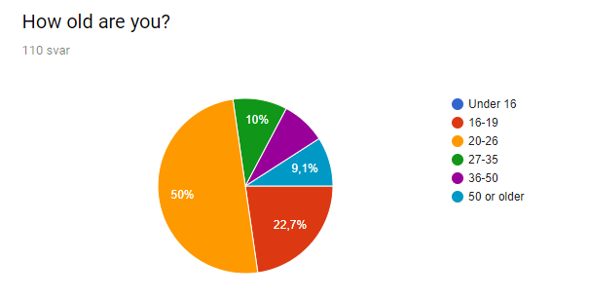

Videre kartlegges hvilket kjønn deltagerne identifiserer seg som. We see from the results below that the participants are evenly distributed between men and women. It would be useful for the development of a product to receive feedback from both women and men. Such a distribution is therefore very positive.

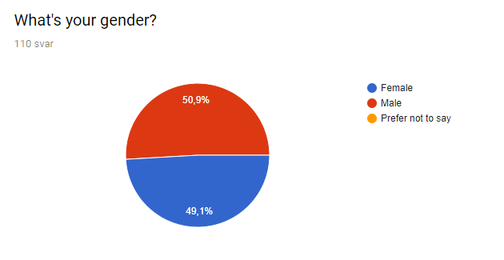

If a person has not applied for a job before, their participation is not relevant to this survey. Therefore persons who have not applied for a job before, be automatically sent to the final page of the survey. As shown by the results, this included 8.2% of the participants. Most of the participants this consist of are in the age group 16-19 years. It includes less than 20% of this group, and therefore will not affect overall result.

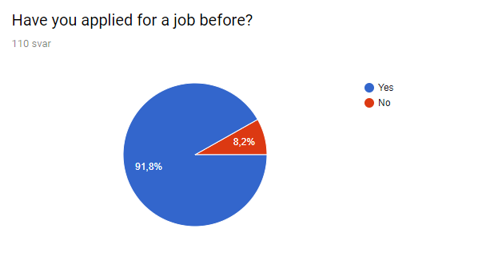

For the development of our potential solution to the problem, it was important to have an overview of which platforms are commonly used to find positions online. We listed the most common options, but it was also important for us to see what people wrote under the "other" option. Here were answers like: recruitment agency, findaPhD.com, on the company's website, academicwork.no, linkedin.com, the newspaper, acquaintances, jobbnorge.no, job.tu.no, frilansbanken.no, indeed.com and mail. Some of these suggestions are not platforms where applications can be submitted, but rather places to find job information. The question must therefore be interpreted as misunderstood. This, however, we did not affect the overall outcome of the survey, as these answers were only meant to be used in the development of the solution to the problem.

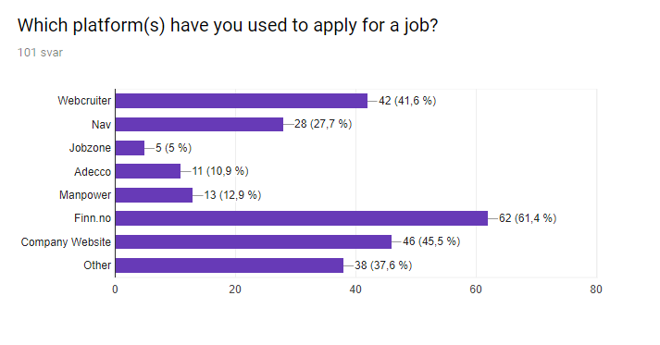

To find the need for a platform that keeps track of your applications, participants were asked if they remember all places they've searched for a job. More than half answered that they remember most of the jobs they have applied for. It is still almost 20% who think they only remember a few. These persons are also in the age group 20-26 years. This may imply that they are or were recently in a job search process.

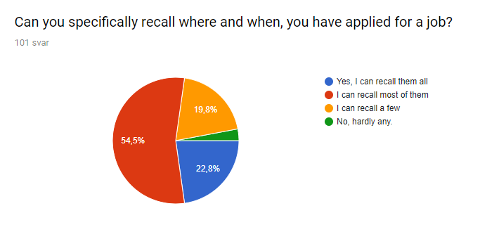

To get a clearer picture of the participants searching process, they were asked what they think is the most challenging. The results show that most people find it hardest to find relevant jobs, closely followed by getting the registry an application. However, we see that a significant amount finds it challenging to remember where applications are registered, as well as to remember deadlines. It appears to be a market for solutions that help job seekers in their everyday lives.

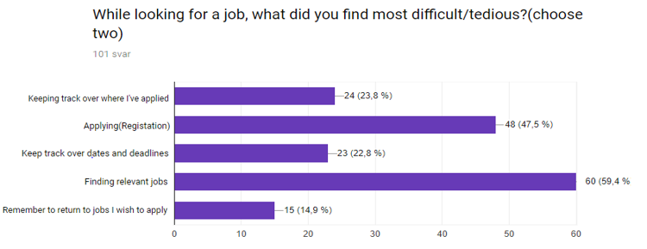

To get a sure answer as to whether there will be a market for a possible solution to the challenges of applying for a job, participants were asked if this would be relevant to them. Here we received a very positive response. More than half answered that they would use such a solution, of which 58.6% were women. It shows that such a product is useable to both genders. A total of 35.6% of the participants also replied that they might use it.

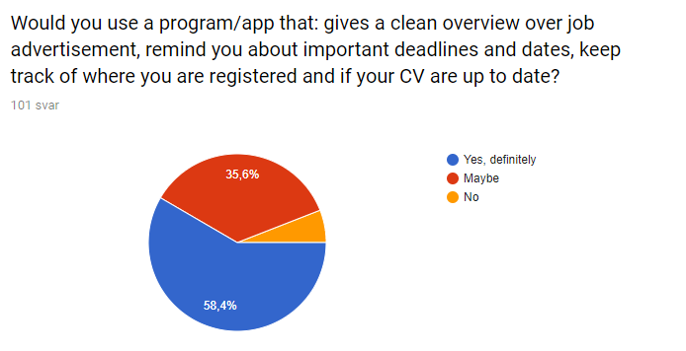

We can conclude that there will be a market for a product that provides a clear overview of job advertisements and applications, which reminds you of important dates and deadlines, which also remind you of where you have registered and whether your CV is up to date.